**Name : Khushi Nitinkumar Patel**

**PRN : 2020BTECS00037**

**Batch : S3**

**LA3 Performance Submission**

**Title :** Design of Universal and Special purpose gates using basic logic gates in proteus.

**Explaination:**

Special gates:XOR,XNOR

Basic gates:AND,OR,NOT

Universal gates:NAND,NOR

1)The AND gate(4081),OR gate(4071),NOR(74S02),XOR(4030),

NOT gate,NAND(4011) are library devices used show the

working of the data in Proteus 8 software

2)Logicstate,logicprobe devices are also used to fetch output

of logic gates.

3) A **universal gate** is a logic gate which can implement any Boolean function without the need to use any other type of logic gate. The NOR gate and NAND gate are universal gates.

**Snapshots**

**NOR**

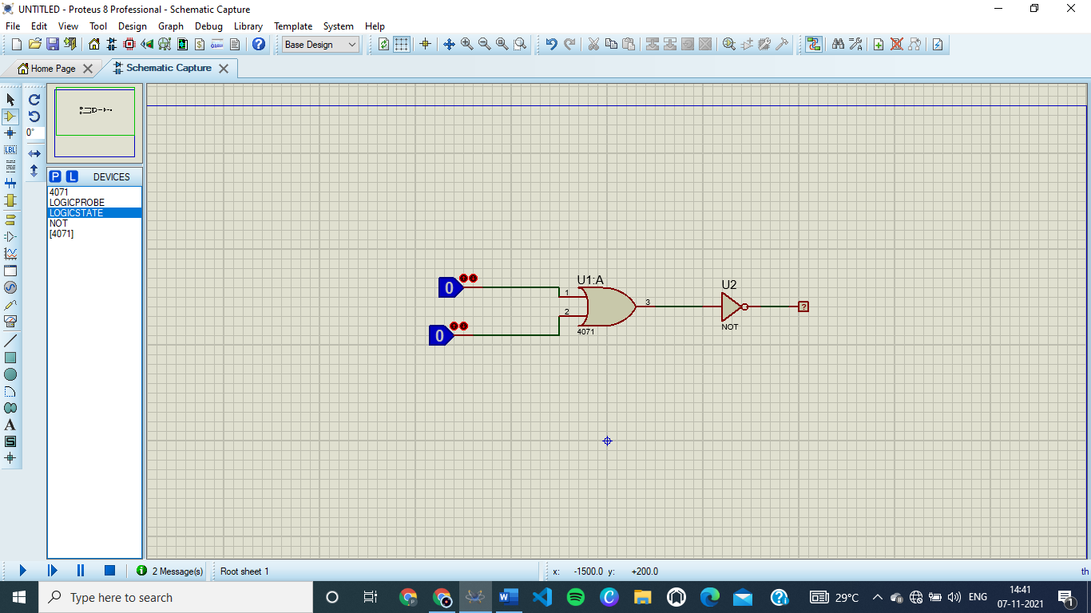

**NOR gate using NOT and OR gate.**

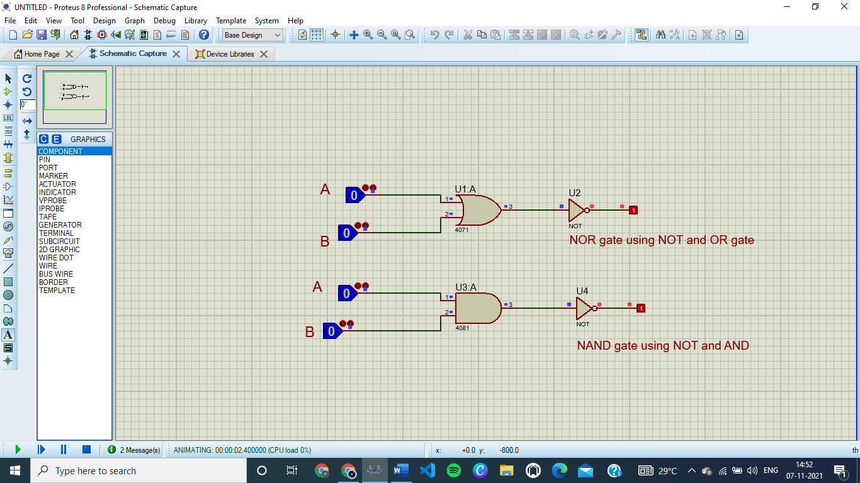

**XOR**

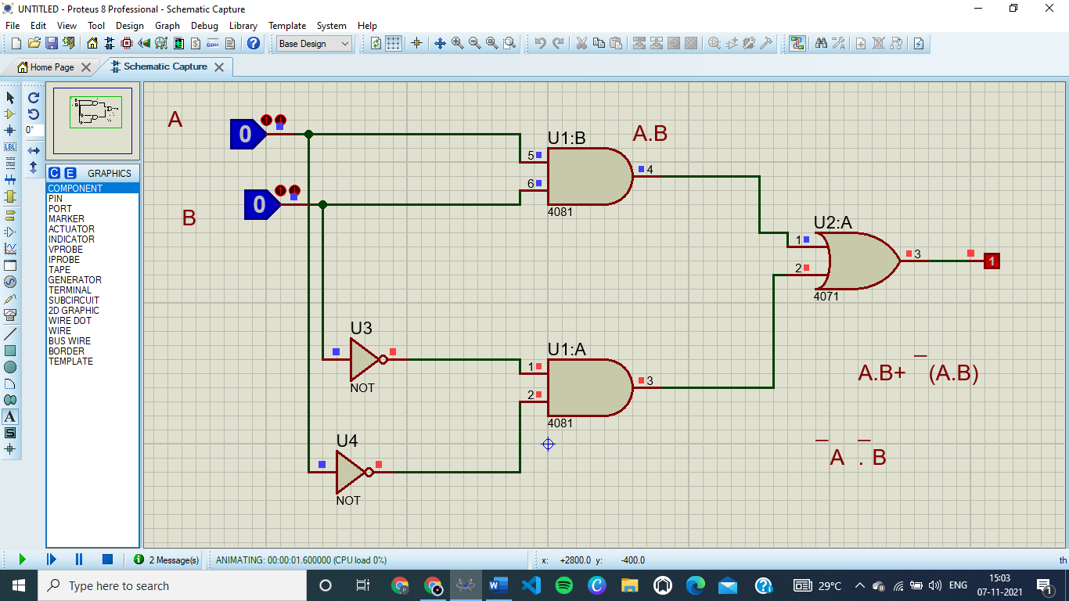

**XNOR**

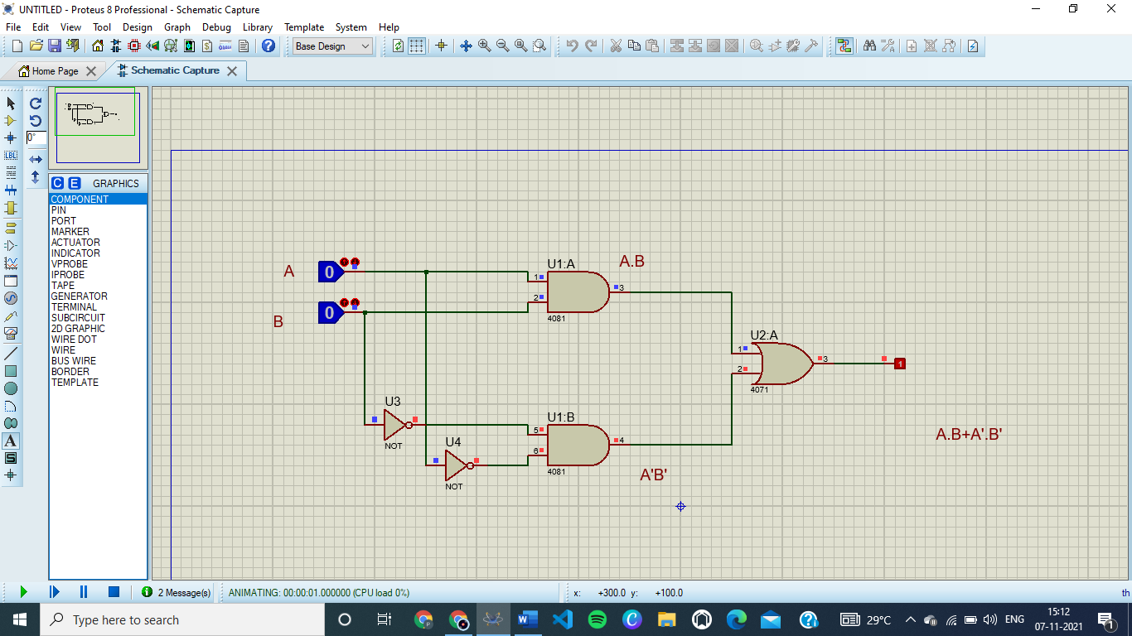

**Conclusion**

Design of Universal and Special purpose gates using basic logic gates in proteus is successfully achieved.